Project Design Phase-II
Data Flow Diagram & User Stories

Date | 30 September 2025
Team ID | SWTID-2026-6249
Project Name | AI FAQ Assistant API
Maximum Marks | 4 Marks
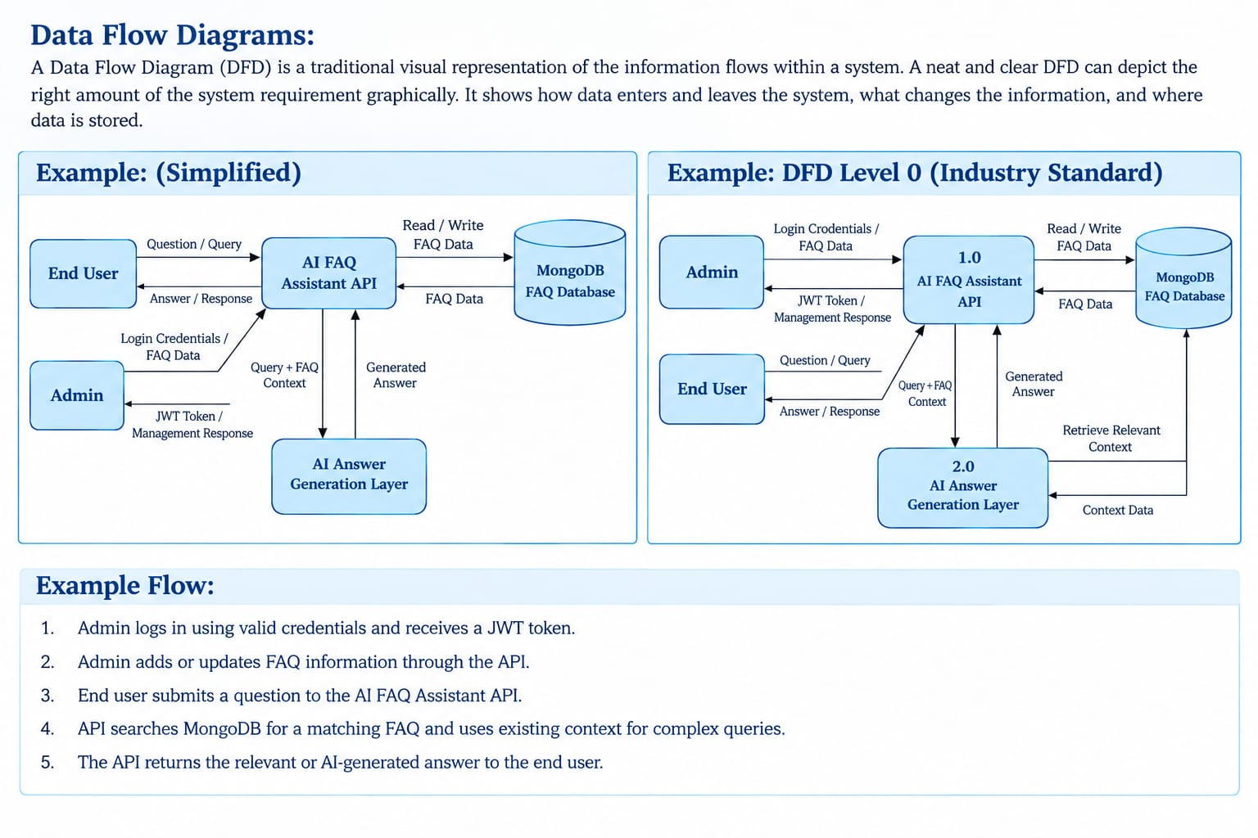

User Stories
User Type | Functional Requirement (Epic) | User Story No. | User Story / Task | Acceptance Criteria | Priority |  | Release
End User | Submit Query | USN-1 | As a user, I can submit a question to the API. | Question is submitted successfully. | High |  | Sprint-1
End User | FAQ Search | USN-2 | As a user, I can receive answers from FAQs. | Relevant answer is displayed. | High |  | Sprint-1
End User | AI Answer | USN-3 | As a user, I can receive AI-generated answers. | AI provides an answer for complex queries. | High |  | Sprint-2
Admin | Login | USN-4 | As an admin, I can log in securely. | JWT token is generated after login. | High |  | Sprint-1
Admin | FAQ Management | USN-5 | As an admin, I can add and update FAQs. | FAQ data is saved or updated in MongoDB. | High |  | Sprint-2
Admin | FAQ Management | USN-6 | As an admin, I can delete FAQs. | Selected FAQ is deleted successfully. | Medium |  | Sprint-2

